**Online Home Food Delivery - Application**

**Project Management Milestone1**

**Group-**

**Project Title:**

Online Home Food Delivery

## **Description:**

This project is about developing an online home food delivery application for mobiles, laptops, and computers. In this project, we will build an application where everyone can order home food online on their machines with one click of installation, instead of going to the restaurant and ordering the food. By this, we can order any food item from anywhere by just installing the application.

#### **Team name:**

## RISERS

## **Team member names:**

1. Pruthvi Raj Padthe
2. Yaswant Lakkaraju
3. Mehal Reddy Mula
4. Roopin Viparthi
5. Mohith Naga Venkata Sai Vanama

**Client: Dr.** Aziz Fellah

## **Team logo:**



## **Working as a team together:**

As a team, we will take responsibility for completing the project on time with the given budget. Along with this, we will not compromise on quality.

## **Team meetings:**

We will meet daily at zoom calls and check if anyone has any issues, and we will try to resolve these issues in the daily meet. Along with this, we will also discuss our future work.

## **Contacting each other:**

We will be communicating using Northwest Email, Zoom, and Skype for Business to have quick online meetings.

## **Dealing with a non-participating team member:**

As a team, we will check whether the project is on track and if any team member is non-participating, we will try to resolve those issues by talking to him. If he is not interested in given work, we will assign the work in which an individual is interested.

|  |  |
| --- | --- |
| **Roles** | **Responsible Team members** |
| Team Lead | Roopin Vipparthi |
| Application Engineer | Mohith Naga Venkata Sai Vanama, Pruthvi Raj Padthe, Yaswant Lakkaraju |
| Application Developer | Mohith Naga Venkata Sai Vanama, Pruthvi Raj Padthe, Yaswant Lakkaraju |
| Project Manager | Mehal Reedy Mula |

## **Roles:**

**Project Manager and Team Lead**

* Arranging daily stand-up meetings
* Arranging Monday Sprint meetings
* Motivating Team
* Analyzing the scope
* Managing the risks
* Keeping track of all requirements
* Assigning tasks
* Communicating with other stakeholders
* Encouraging the team
* Providing guidance and instructions to team members

## **Application Engineer:**

* Developing and implementing Application software
* Ensuring that the Application design is fully implemented and performs as expected
* Creating unit tests and validation procedures and documenting technical specifications
* Working closely with a lead to create task/project deliverables
* Interface with Quality Assurance, Application Designers, Artists, Mathematicians, and Sound Designers

## **Application Developer:**

* Creating web application using various scripting languages and tools
* Meeting the requirements
* Meeting the given deadlines
* Time management

Project Charter

Date: 05/16/2021

|  |  |  |  |
| --- | --- | --- | --- |
| **Project Title**: Online Home Food Ordering Application | | | |
| **Project Start Date:** 05/16/2021 **Projected Finish Date:** June 2021 | | | |
| **Budget Information:** This project would cost around 15,000 dollars to complete**.** | | | |
| **Project Manager:** Mehal Reddy Mula, S542312@nwmissouri.edu | | | |
| **Project Objectives:**  The project's main objective is to learn and implement a real-time application on the Online Home Food Ordering System database. The project concentrates on taking orders, streamlining the orders to a specified Home, and billing. This Database will be an excellent solution for many start-up food businesses, and they can start initially with fewer funds by posting their menu online with this application. | | | |
| **Success Criteria:**Before the deadline, we, the expert team of Application Engineers, will finish our application with the competence and skills needed to complete our project with a bug-free, user-friendly design, and it will be on live with Good Implementation. | | | |
| **Approach:**  **AGILE APPROACH** | | | |
| **Roles and Responsibilities** | | | |
| ***Name and Signature*** | ***Role*** | ***Position*** | ***Contact Information*** |
| 1. Roopin Vipparthi | Team Lead | Team Lead | S542274@nwmissouri.edu |
| 1. Mohith Naga Venkata Sai Vanama | Team Member | Application Engineer/ Application Developer | S543064@nwmissouri.edu |
| 1. Yaswant Lakkaraju | Team Member | Application Engineer/ Application Developer | S542297@nwmissouri.edu |
| 1. Pruthvi Raj Padthe | Team Member | Application Engineer/ Application Developer | S542052@nwmissouri.edu |
| 1. Mehal Reddy Mula | Project Manager | Project Manager | S542312@nwmissouri.edu |
|  | | | |
| **Comments:** (Handwritten or typed comments from above stakeholders, if applicable) | | | |

Stakeholder Register for Online Home Food Delivery

**Prepared by:** Pruthvi Raj Padthe **Date: 05/16/2021**

|  |  |  |  |  |
| --- | --- | --- | --- | --- |
| **Name** | **Position** | **Internal/External** | **Project Role** | **Contact Information** |
| Roopin Vipparthi | Team Lead | Internal | Team Lead | S542274@nwmissouri.edu |
| Mohith Naga Venkata Sai Vanama | Team Member | Internal | Applicaion Engineer/ Application Developer | S543064@nwmissouri.edu |
| Yaswant Lakkaraju | Team Member | Internal | Applicaion Engineer/ Application Developer | S542297@nwmissouri.edu |
| Pruthvi Raj Padthe | Team Member | Internal | Applicaion Engineer/ Application Developer | S542052@nwmissouri.edu |
| Mehal Reddy Mula | Project Manager | Internal | Project Manager | S542312@nwmissouri.edu |
| Aziz Fellah | Client | External | End User | AFELLAH@nwmissouri.edu |

**Signatures:**

Roopin Vipparthi:

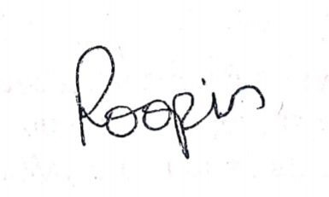

Mohith Naga Venkata Sai Vanama:

Yaswant Lakkaraju:

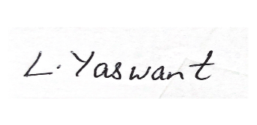

Pruthvi Raj Padthe :

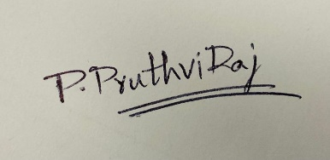

Mehal Reddy Mula :

